CAP 6675: Complex Adaptive Systems Homework 3

# INTRODUCTION

Ant colonies are complex systems whose components, ants, have roles and social interactions that are important to study adaptive mechanisms such as division of labor. Particularly, an approach in which we base our article to study the phenomenon of division of labor is making use of a response threshold reinforcement procedure in the fashion presented by Theraulaz et al. [2]. Therefore, our purpose is to study whether a genetic caste system affects all individual ants to become either specialists or non-specialists of the tasks of defense, brood care, and foraging. More specifically we care to see whether such a genetic caste system can make ants less sensible to forgetting skills they need to learn to become specialized in the tasks they perform.

We extend the work of Theraulaz et al [2] and use their forgetting rate and learning rate variables to study a genetic predisposition that we are introducing, a caste system. Then, our research question is: does a caste system affect time convergence of specialization for different values of the forgetting rate? And our hypothesis: a caste system can make ants more resistant to a higher forgetting rate, that is, the “forgetting rate range” until all ants become non-specialists is longer in the caste system than in the original program when the caste system is implemented.

# EXPERIMENTAL METHOD

## Base model

### Threshold response values

In our implementation of the base model, the initial configuration of threshold response values for all ants are randomly chosen in a uniform fashion for values within 1 and 1000. This means that the model may start with specialized ants in one or more tasks, or non-specialised.

Stimuli equation and manual settings

In the model, a demand-schedule mechanism was implemented to mimic a natural demand change in the ant colony from external stimuli. Implemented as a switch, a user can toggle the demand-schedule function and manually change the demand for each task to make ants specialize and respecialize during the run of the model in real-time.

### Removal and reintroduction

A manual removal and reintroduction function were implemented on the model to increase control of results and experimentation during a simulation run via buttons named ‘removal’ and ‘reintroduction’ respectively. The removal function is implemented and anchored around the defense task. The defense task specialization is visualized as ants with green color which allows the removal function to search for all green ants and turn them white. White indicates that the ant was removed from the colony but was not removed completely from the program to keep its original threshold values for later reintroduction. The premise of the removal function being based around the defense task was to observe to which degree will removing ants from the defense task cause ants from the neighboring tasks to fill in the demand for the defense task.

The reintroduction function is then implemented by choosing one of the removed ants (white color ants) and requesting the ant to select a task which will cause it to pick its previous specialized task due to the original threshold values when removed from the colony. As before with the removal case, once we observe ants from the brooding and foraging task move to the defense task, the removed ants are reintroduced and we monitor the time it takes for the previous ants to return to their original tasks.

## Extended model

### Genetically predisposed caste system

We consider three different types of genetically predisposed types of ants, that is, our caste system is composed of soldier ants which are more predisposed to specialize as colony defenders, foragers predisposed to become foragers, and nurses predisposed to primarily perform brood care tasks. In our model we set the initial threshold ($θ$) of the castes to near specialization threshold value according to its task predisposition and not too far from non-specialization for the rest (Theraulaz et al [2] use 500 for the values of indifferent predisposition to a task at model initialization, therefore we chose this value for the non-predisposition). The caste thresholds for all three tasks we chose in our model are the following:

$θ_{soldier-defense}= 200; θ_{soldier-foraging}= 500; θ_{soldier-brood care}= 500$

$θ_{forager-defense}= 500; θ_{forager-foraging}= 200; θ_{forager-brood care}= 500$

$θ_{nurse-defense}= 500; θ_{nurse-foraging}= 200; θ_{nurse-brood care}= 500$

### Forgetting rate range

In our model to capture whether all individual ants become either specialists or non-specialists of the tasks of defense, brood care, and foraging, we use the concept of time convergence ($T_{c }$) from Theraulaz et al. [2] which marks the time in which all the ants will reach the point of specialization or non-specialization described. Formally, when all the ant’s thresholds in a trial reach a threshold value of <100 or >900 for all the tasks they can perform we say that convergence has been reached and our program stores the respective $T_{c}$ moment where this happened. Then we will test time convergence for all forgetting rates until absolutely all ants become non-specialized, that is no ant will have a specialization at this point. Therefore, our program will output a list of the time of convergence for each forgetting rate reached. The forgetting rate increments by 0.1 starting at 0.01 for 100 ants, N = 100.

As well, to make our results more clear we output the number of specialists at brood care $N_{brood-care}$, number of specialists at defense $N_{defense}$, and number of specialists at foraging $N_{foraging}$ at every step of the forgetting rate.

To test our hypothesis, we will compare the number of ants specialized in each task for every forgetting step and the highest forgetting rate reached until all ants become non-specialized with the caste system off in contrast to the data collected with the caste system on. Also, for further explanation we will show the pattern of these results including the number of specialists at every task at each step of the forgetting rate.

# 

# RESULTS

We produced four sets of results for testing for all the combinations when genetic predisposition (caste system) is on and off, and our demand schedule is off or on. Also, we perform the experiments with a total population of 100 ants. The values we chose for the demand schedule are determined by an optimal stimuli motivation based on the studies by Charbonneau et al. [1], and the ones we found on scientific online magazines [3, 4] such that the foraging probability = 0.37, brood care probability = 0.16, and defense probability = 0.07. These values make sense in that it turns out that these studies found that ~40% of ants in a colony are inactive at any moment.

In our model we are interested in the performance of our tasks, so we are considering an entire set of ants that are active all the time, for this we adjust the described probabilities to be foraging probability = 0.37/0.60 = 0.62, brood care probability = 0.16/0.60 = 0.26, and defense probability = 0.12, these values are our parameters of the demand schedule. Then, the experiments we performed as shown in Figures 1 to 4, clearly show that the forgetting rate for all of our configurations are higher in the system when the caste system is off. When the demand schedule is off the original system has a resistance up to 3.61 against 3.01 when the predisposition system is on. When the demand schedule is on the original system has a resistance up to 9.21 against 5.41 when the predisposition system is on.

# CONCLUSION

The results prove that our hypothesis is false, therefore the genetic predisposition settings we used make the ant colony more susceptible to become unspecialised for high forgetting rates in contrast to a non-predisposed system. Moreover, our results and method are useful to optimize initial parameters related to threshold response such as forgetting rate, learning rate and probability of an ant becoming inactive, for the AC model by Theraulaz et al. [2] and potentially for other AC systems that use threshold reinforcement techniques. As well, our model can be used for testing different configurations for systems that rely on genetic predisposition to tasks, or even social predispositions where roles are important.

**REFERENCES**

[1] Charbonneau, Daniel, et al. “Who Needs ‘Lazy’ Workers? Inactive Workers Act as a ‘Reserve’ Labor Force Replacing Active Workers, but Inactive Workers Are Not Replaced When They Are Removed.” *PLOS ONE*, vol. 12, no. 9, 2017, <https://doi.org/10.1371/journal.pone.0184074>.

[2] Theraulaz, G., et al. “Response Threshold Reinforcements and Division of Labour in Insect Societies.” *Proceedings of the Royal Society of London. Series B: Biological Sciences*, vol. 265, no. 1393, 1998, pp. 327–332., <https://doi.org/10.1098/rspb.1998.0299>.

[3] “Study Reveals How Forager Ants Keep Their Colonies Well Fed.” *ELife*, ELife Sciences Publications, Ltd, 13 Mar. 2018, <https://elifesciences.org/for-the-press/55c278f8/study-reveals-how-forager-ants-keep-their-colonies-well-fed>.

[4] “The Making of Soldier Ants.” *ScienceDaily*, ScienceDaily, 10 Oct. 2018, https://www.sciencedaily.com/releases/2018/10/181010132357.htm.

**FIGURES**

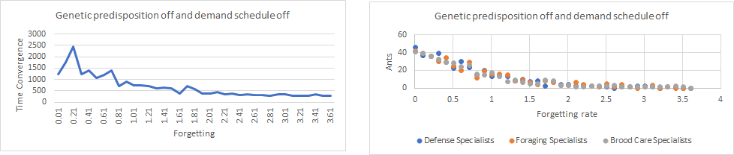  
Figure 1. Caste system off with demand schedule off for forgetting steps of 0.1. Our highest forgetting rate until total non-specialisation is 3.61.

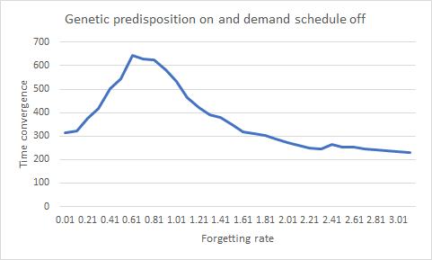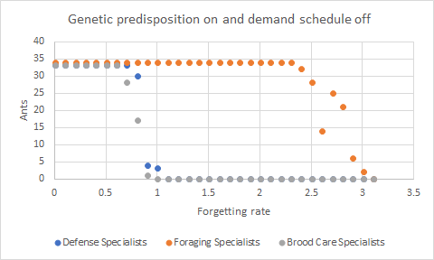  
Figure 2. Caste system on with demand schedule off for forgetting steps of 0.1. Our highest forgetting rate until total non-specialisation is 3.01.

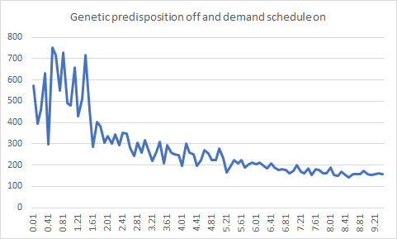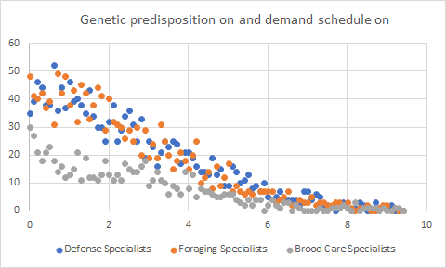  
Figure 3. Caste system off with demand schedule on for forgetting steps of 0.1. Our highest forgetting rate until total non-specialisation is 9.21.

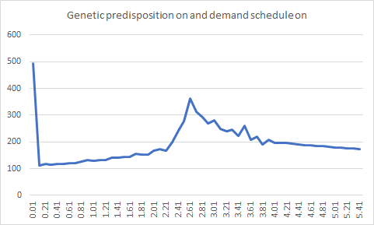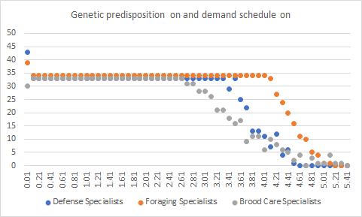  
Figure 4. Caste system on with demand schedule on for forgetting steps of 0.1. Our highest forgetting rate until total non-specialisation is 5.41